# CS 255 System Design Document Template

This template lays out all the different sections that you need to complete for Project Two. Each section has guidance to prompt your thinking. You will need to continually reference the interview transcript as you work to make sure that you are addressing your client’s needs. There is no required length for the final document. Instead the goal is to complete each section based on what your client’s needs are. Remove this note when you are finished, and replace all bracketed text with the relevant information.

## UML Diagrams

### UML Use Case Diagram

*[In Module Six, you were asked to complete a use case diagram based on your system design. If you would like to make any adjustments to your diagram, please do so. Please insert your use case diagram here. Check to make sure that you included appropriate components and symbols and that your design meets the client’s needs.]*

### UML Activity Diagrams

*[You were asked to choose* ***two*** *use cases and create* ***two*** *activity diagrams, one for each use case. Please insert* ***both*** *of your activity diagrams here. Check to make sure that you included appropriate components and symbols and that your design meets the client’s needs.]*

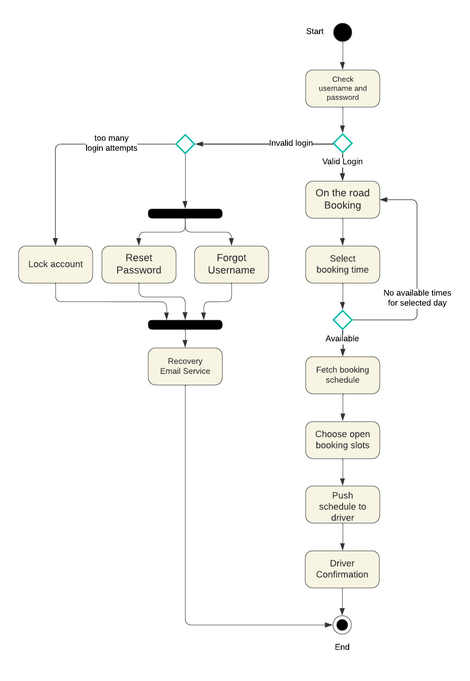

### UML Sequence Diagram

*[You were asked to create a sequence diagram based on* ***one*** *of the use cases you chose. Please insert your sequence diagram here. Check to make sure that you included appropriate components and symbols and that your design meets the client’s needs.]*

### UML Class Diagram

*[You were asked to create a class diagram based on the different classes and attributes needed for your system design. You are* ***not*** *required to include methods, but you may if you wish. Please insert your class diagram here. Check to make sure that you included appropriate components and symbols and that your design meets the client’s requirements.]*

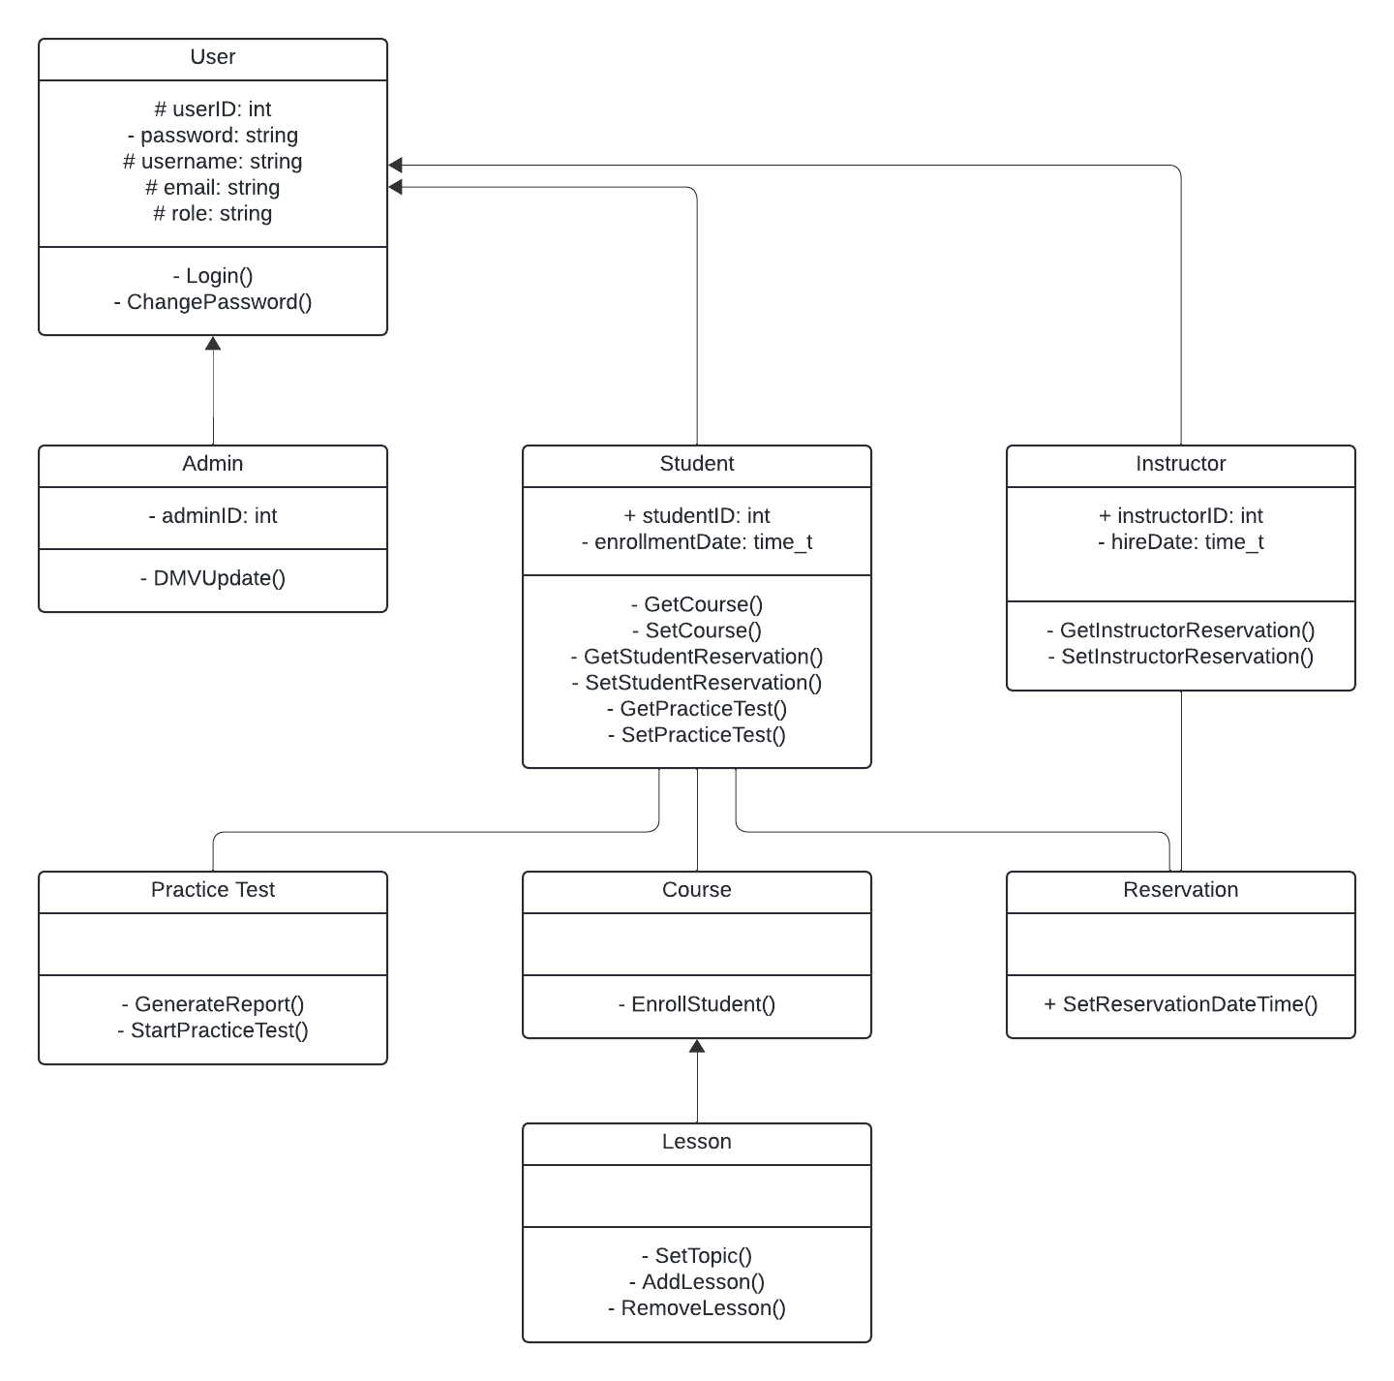

## Technical Requirements

*[Based on the diagrams you have created, describe the technical requirements of your system. These requirements should address the required hardware, software, tools, and infrastructure necessary for your system design.]*

**Hardware Requirements**

* Network equipment necessary for managing virtual network services provided by the cloud platform to manage network traffic and communication.
* Server infrastructure provided by the cloud platform from a reputable service provider such as Amazon Web Services (AWS) or Microsoft Azure to host the DriverPass application.

**Software Requirements**

* Encryption Libraries are necessary for handling data in motion and at rest.
* Using a relational database management system like MySQL to be able to store and manage data.
* Version control systems such as Git are necessary to maintain the codebase in a collaborative effort while offering the ability to rollback as well as compare versions.

**Infrastructure Requirements**

* A reliable high-speed internet connection is required to access cloud services and maintain service connections.
* Disaster recovery systems, such as backups, are necessary to ensure downtime remains low and damages are lessened through this form of digital insurance.